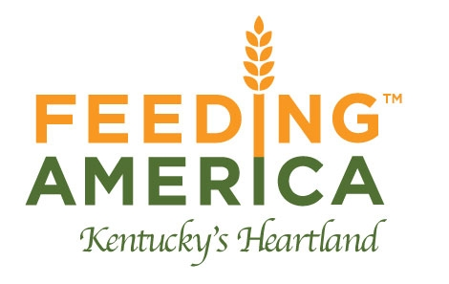

COVID-19 Policy Information
Revised August 10, 2022
This is a temporary policy and due to the rapidly changing circumstances it may be modified or ended at any time to support business and health needs.
As part of our coordinated response to the effects of COVID-19, we have developed a temporary policy to further support the health and wellbeing of Food Bank staff.
- You will continue to report to work, and we will continue to take measures to protect your health and safety.
If you are ill, or become ill with fever and/or symptoms of COVID-19 (fever or chills, cough, shortness of breath/difficulty breathing, fatigue, muscle/body aches, headache, new loss of taste/smell, sore throat, congestion or runny nose, nausea/vomiting, diarrhea) regardless of vaccination status, do not report to work; stay home and seek medical advice.
- If you have a confirmed or suspected case of COVID-19 regardless of vaccination status, you must inform your supervisor, provide a medical statement with diagnosis, stay home and follow all directions from your healthcare professional.
- If you have a household member or have had close contact with someone who may not be feeling well but is not suspected or confirmed with having COVID-19, you can come to work.
- If you have a household member or have had close contact with someone who has a suspected or confirmed case of COVID-19 and you have NO SYMPTOMS, follow the CDC’s guidelines listed below:

- You do not need to quarantine if you do not have symptoms.
- Get tested 5 or more days after the last day you were exposed to COVID-19.
- If you develop symptoms, get tested for COVID-19.
- Wear a mask in indoor public settings for 10 days after your last day of exposure.
- Monitor for symptoms for 10 days following your last day of exposure.
- Consider wearing a mask at home if you live with persons who are at high-risk.
* The CDC recommends that anyone with any signs or symptoms of COVID-19 get tested, regardless of vaccination status or prior infection.
* Please refer to FAKH Leave of Absence Policy (section 3.3)
Staff who test positive or have been exposed to COVID-19, must contact their Supervisor, HR, or the Executive Director immediately. Staff privacy will be honored and balanced against FAKH responsibility to ensure a safe workplace for all staff members.
COVID-19 could affect FAKH operations due to staff members being unable to physically work due to their own health condition, the health condition of a family member, and/or the facility is temporarily closed due to the public emergency.
In response to the public health emergency:
- Upon approval by the Executive Director, this policy will allow for employee compensation for up to two weeks during the time period that the facility is temporarily closed or an employee is instructed to stay home and not report to work by a healthcare professional due to the public health emergency.
- Total employee compensation under this policy will not exceed two weeks, or 80 hours, and will not affect employee PTO.

